

***GBS Asset Tracking System***

***BackOffice App***

***Documentation***

Table of Contents

Sign in Screen: 6

1. Sign in 6

DashBoard: 7

1. Dashboard 7

Master Data – Asset Categories 8

1. Asset Main Category 8

2. Asset Sub Category 1 9

3. Asset Sub Category 2 10

4. Asset Sub Category 3 10

Master Data - Brand 11

1. Brand 11

Master Data - Locations 12

1. Branch 12

2. Site 12

3. Building 13

4. Floor 13

5. Room 14

Master Data – Employees 14

1. Employee 14

Master Data – Employees – Departments 15

1. Department 15

2. Section 15

Master Data – Charts of Accounts 16

1. Charts of Account 16

Master Data – Adjustment Types 17

1. Adjustment Types 17

Master Data – List of Values 17

1. Asset Condition 17

2. Retirement Type 18

3. Asset Group 18

Master Data - Accounts 19

1. General Accounts 19

2. Category Accounts Setup 19

Master Data – Cost Center 20

1. Cost Center 20

Asset Transactions – Register 21

1. Register Asset (Asset Information). 21

2. Register Asset (Asset Financial Details) 22

3. Register Asset (Asset Accounting Setup) 22

4. Register Asset (Additional Data) 23

5. Register Asset (Asset Photo) 23

Asset Transactions – Register 24

1. Register IT Asset (Asset Record) 24

2. Register IT Asset (Information Security Department) 24

3. Register IT Asset (Mandatory for H/W Assets Recording) 25

4. Register IT Asset (Mandatory in S/W Assets Recording) 25

5. Register IT Asset (Asset Financial Details) 25

6. Register IT Asset (Asset Accounting Setup) 26

7. Register IT Asset (Additional Data) 26

8. Register IT Asset (Asset Photo) 26

Asset Transactions - Register 27

1. Import & Export Asset Data 27

Asset Transaction – Edit 27

1. Edit Asset (Asset Information) 27

2. Edit Asset (Asset Financial Details) 28

3. Edit Asset (Asset Accounting Setup) 28

4. Edit Asset (Additional Data) 28

5. Edit Asset (Asset Photo) 29

Asset Transactions – Delete 29

1. Delete 29

Asset Transactions – Transfer 29

1. Transfer 29

Asset Transactions – Adjustments 30

1. Adjust Asset 30

Asset Transactions – Change Category 30

1. Change Category 30

Asset Transactions – Retirement 31

1. Asset Retirement 31

Asset Transactions – Add to WIP Asset 31

1. Add to WIP Asset 31

Asset Transactions – Capitalize WIP Asset 32

1. Capitalize WIP Asset 32

View – View Asset 32

1. View Asset (Asset Information) 32

2. View Asset (Asset Financial Details) 33

3. View Asset (Asset Accounts Details) 33

4. View Asset (Additional Data) 33

5. View Asset (Transaction History (No Depr)) 34

6. View Asset (Transaction History (With Depr)) 34

7. View Asset (Depreciation History) 34

8. View Asset (Accounting Transaction History) 35

9. View Asset (Asset Photo) 35

View - View Transaction and Accounting History 35

1. View Transaction and Accounting History 35

Depreciation - Depreciation and Periods Control 36

1. Depreciation and Periods Control 36

Physical Counting – Inventory Order 37

1. Inventory Order 37

2. Assign Location to Users 37

3. Tracking Process 38

4. Asset Audit Result 38

Physical counting - Physical Count Correction Actions 39

1. Location Difference Correction 39

2. Missing Assets Correction 39

3. Approve New Conditions Correction 40

Settings 40

1. User 40

2. Role 41

3. View Role 41

Reports 42

1. Menu 42

# Sign in Screen:

## Sign in

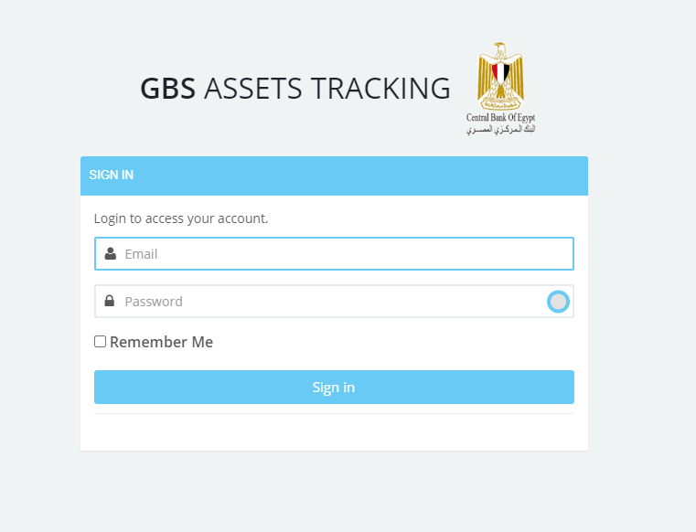

# DashBoard:

## Dashboard

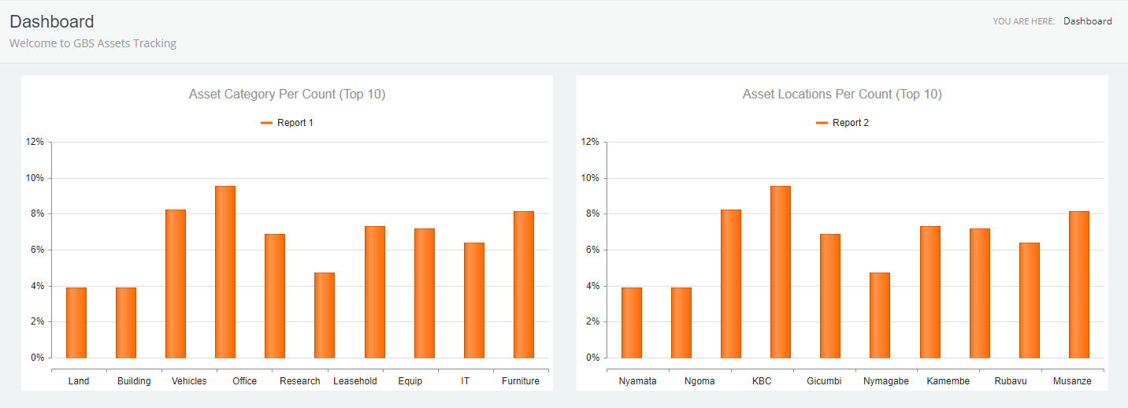

# Master Data – Asset Categories

## Asset Main Category

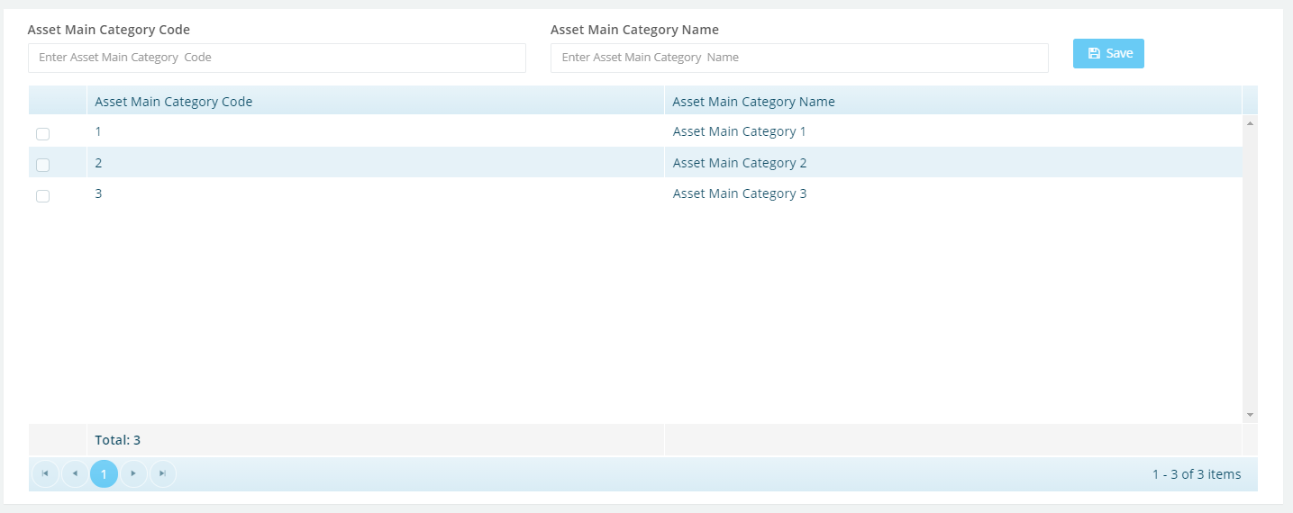

## Asset Sub Category 1

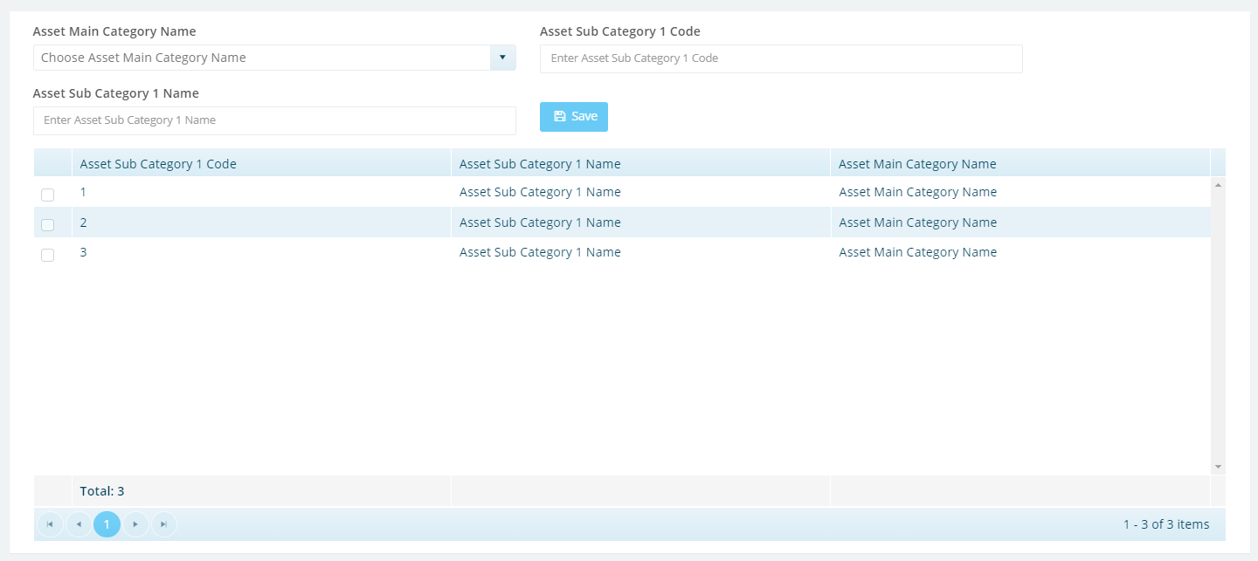

## Asset Sub Category 2

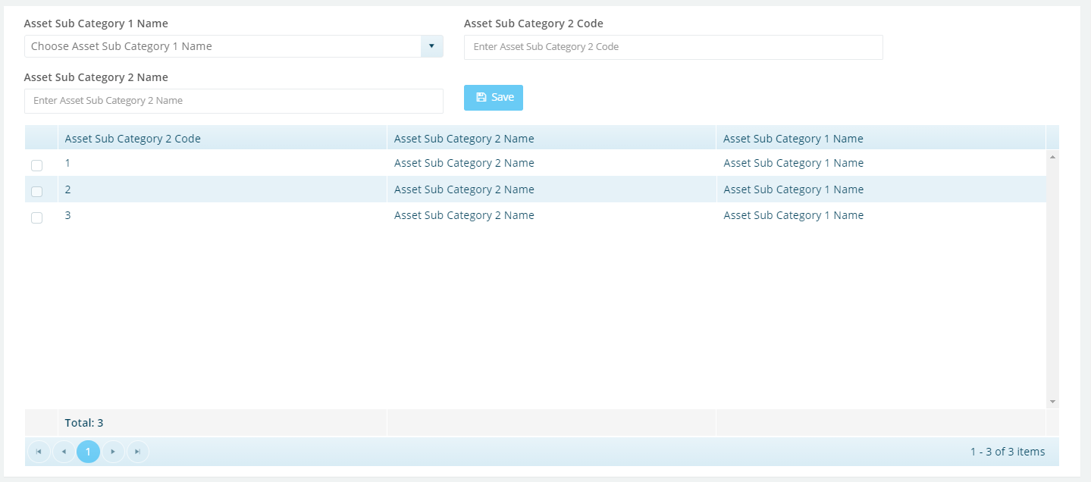

## Asset Sub Category 3

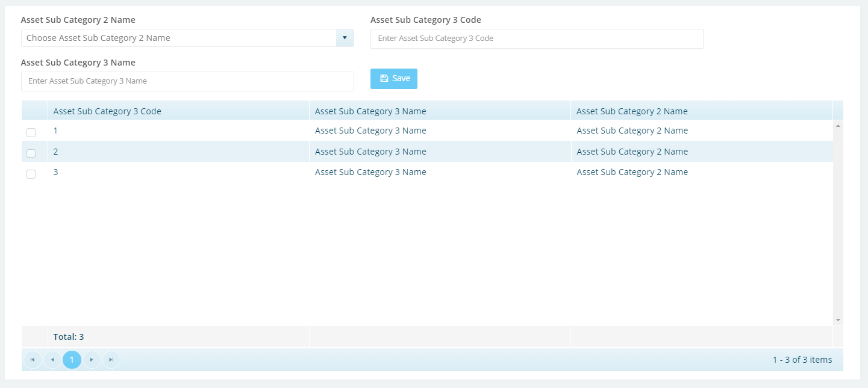

# Master Data - Brand

## Brand

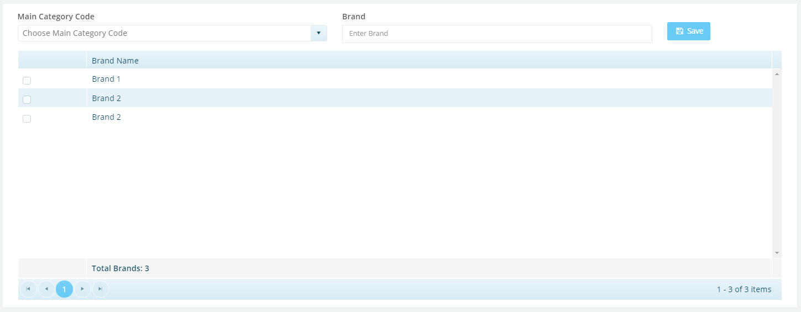

# Master Data - Locations

## Branch

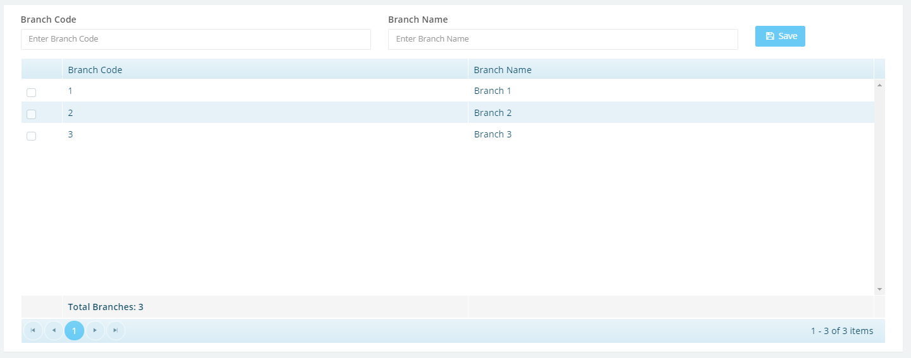

## Site

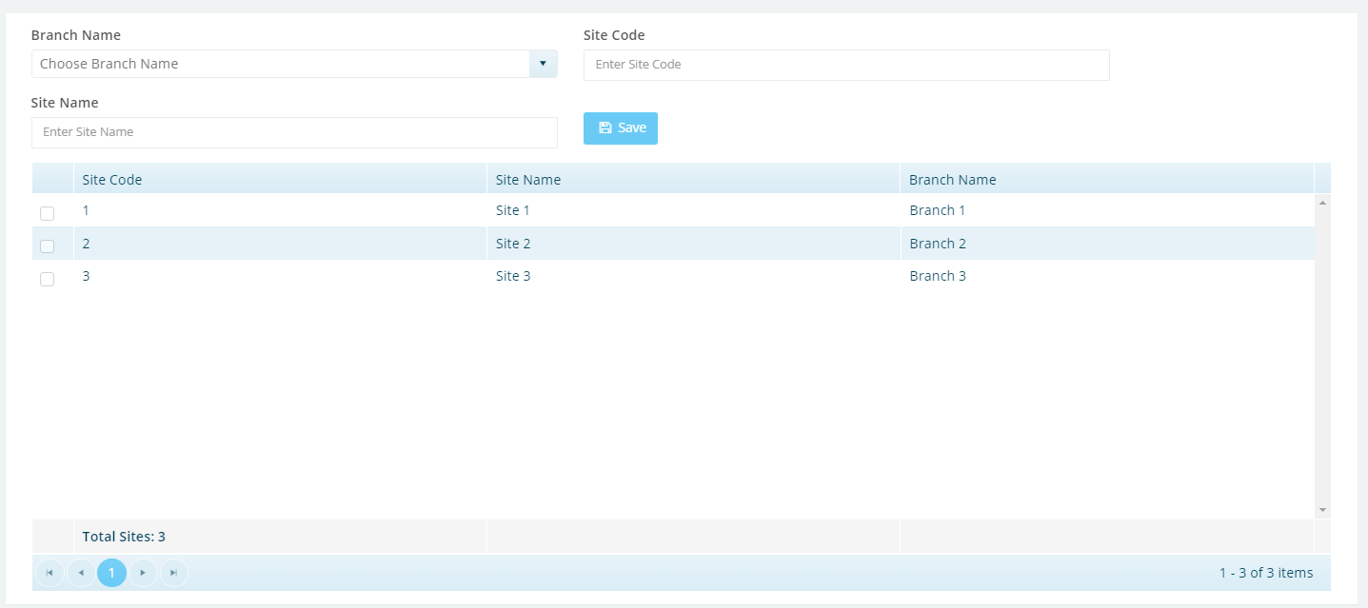

## Building

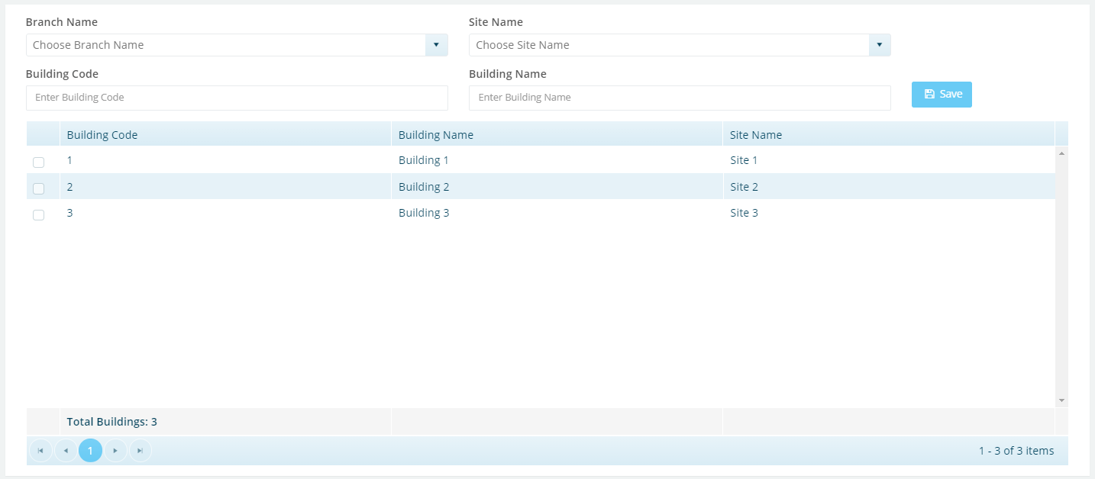

## Floor

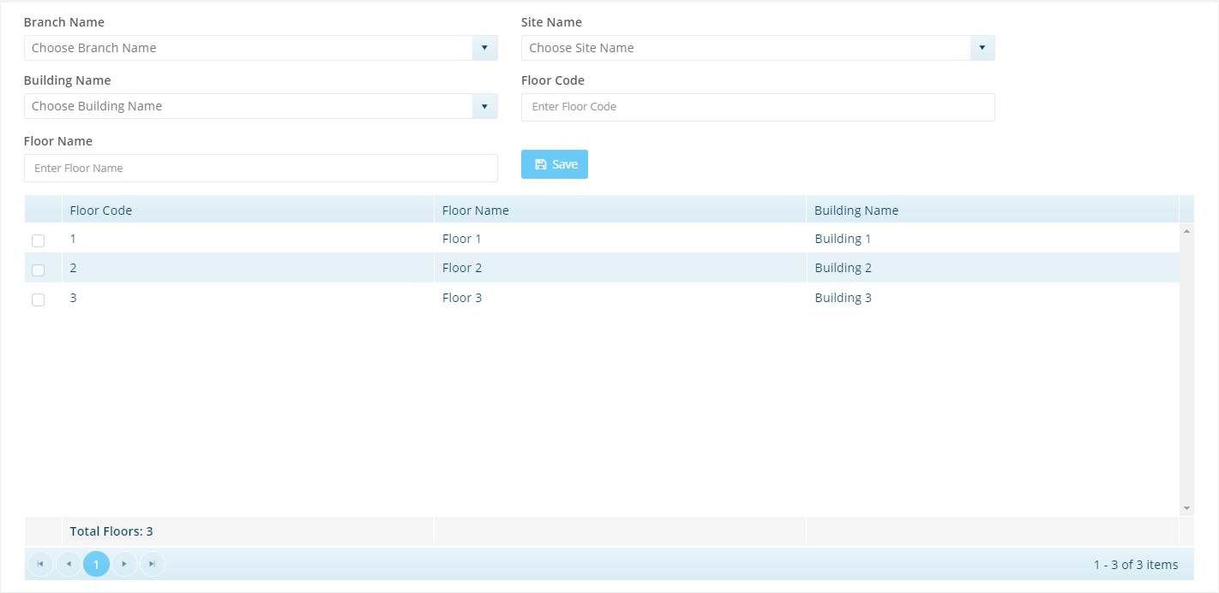

## Room

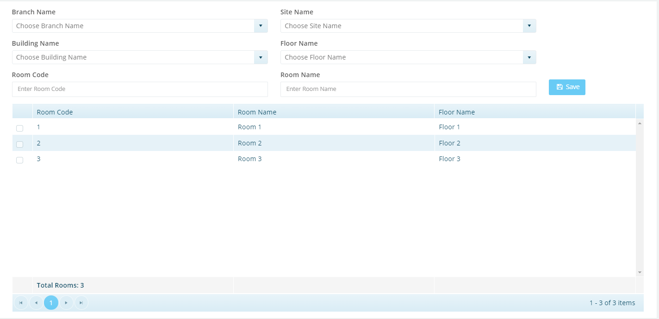

# Master Data – Employees

## Employee

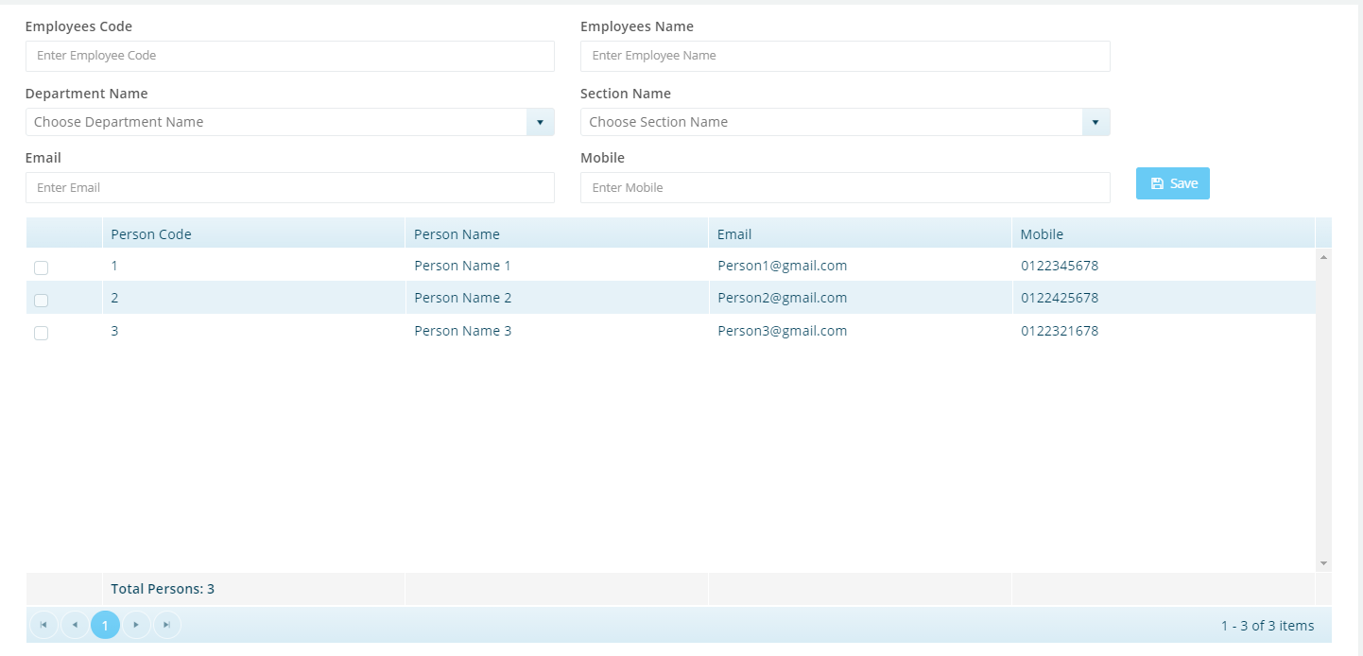

# Master Data – Employees – Departments

## Department

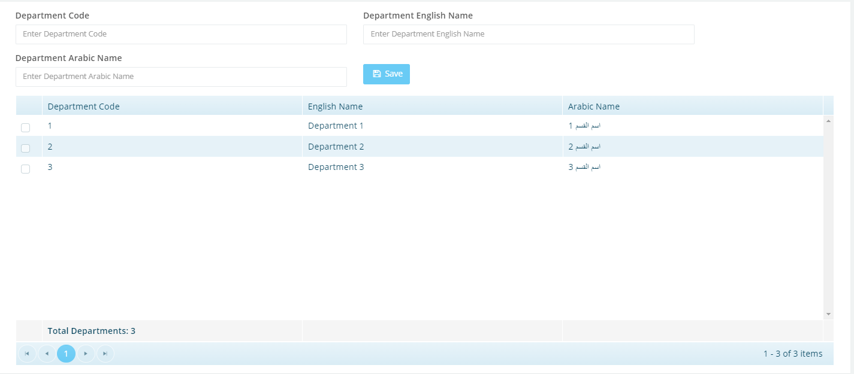

## Section

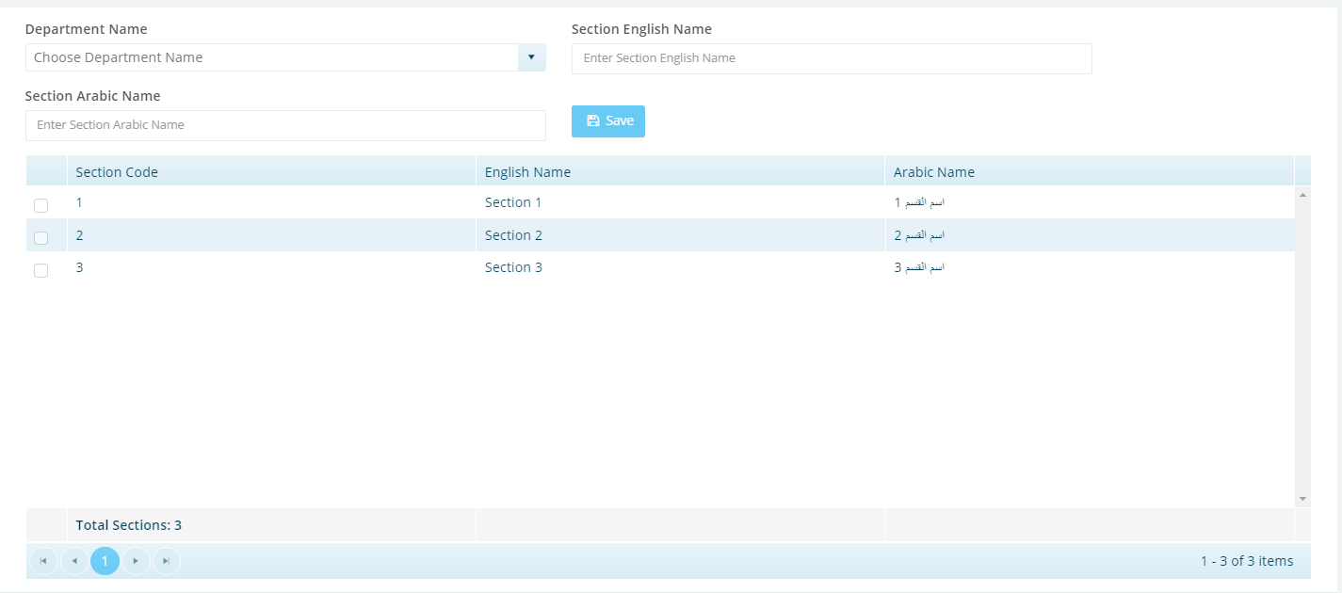

# Master Data – Charts of Accounts

## Charts of Account

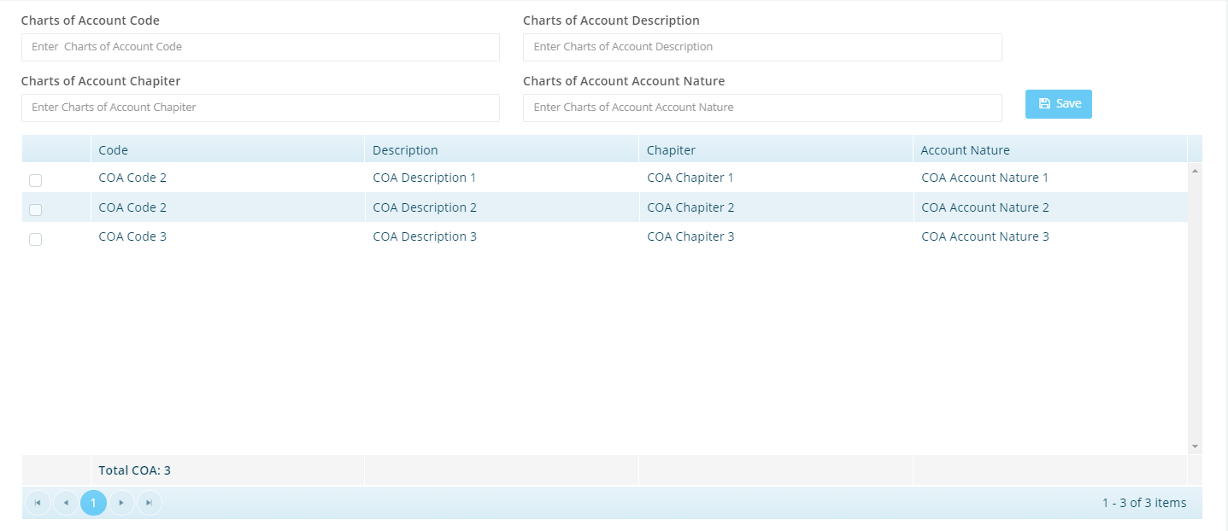

# Master Data – Adjustment Types

## Adjustment Types

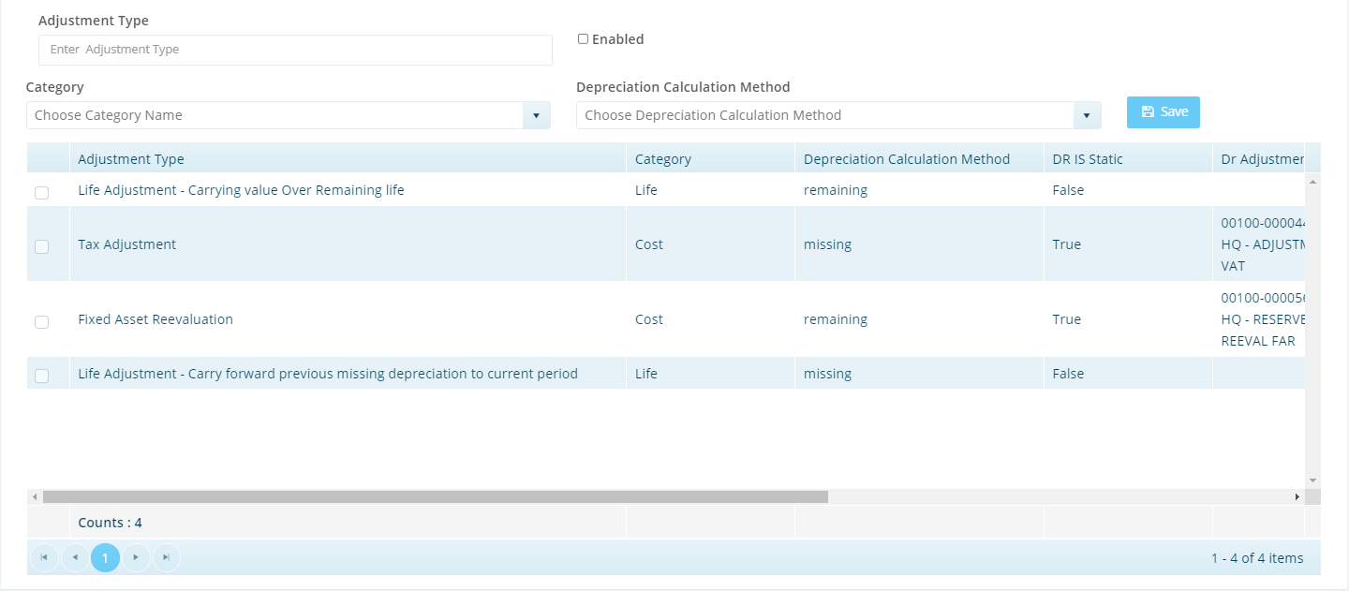

# Master Data – List of Values

## Asset Condition

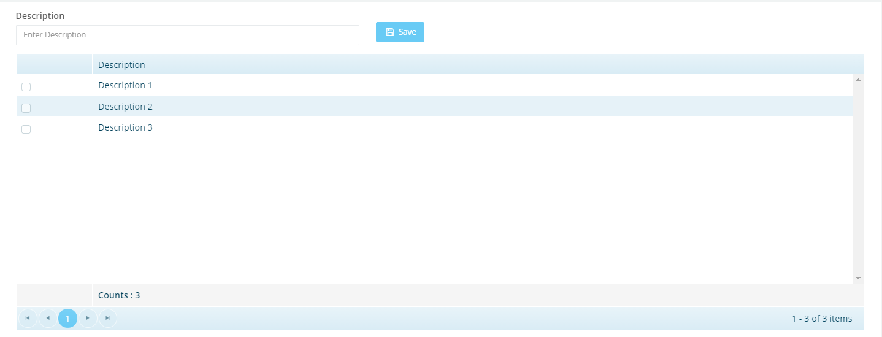

## Retirement Type

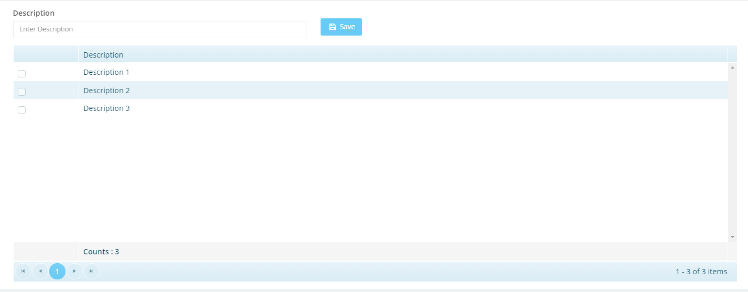

## Asset Group



# Master Data - Accounts

## General Accounts

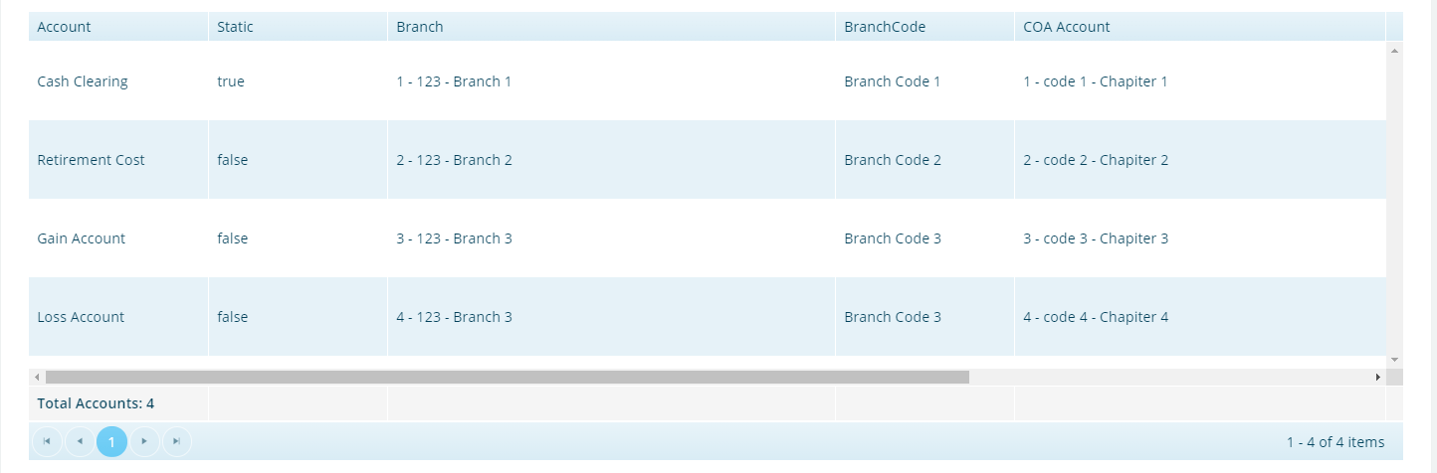

## Category Accounts Setup

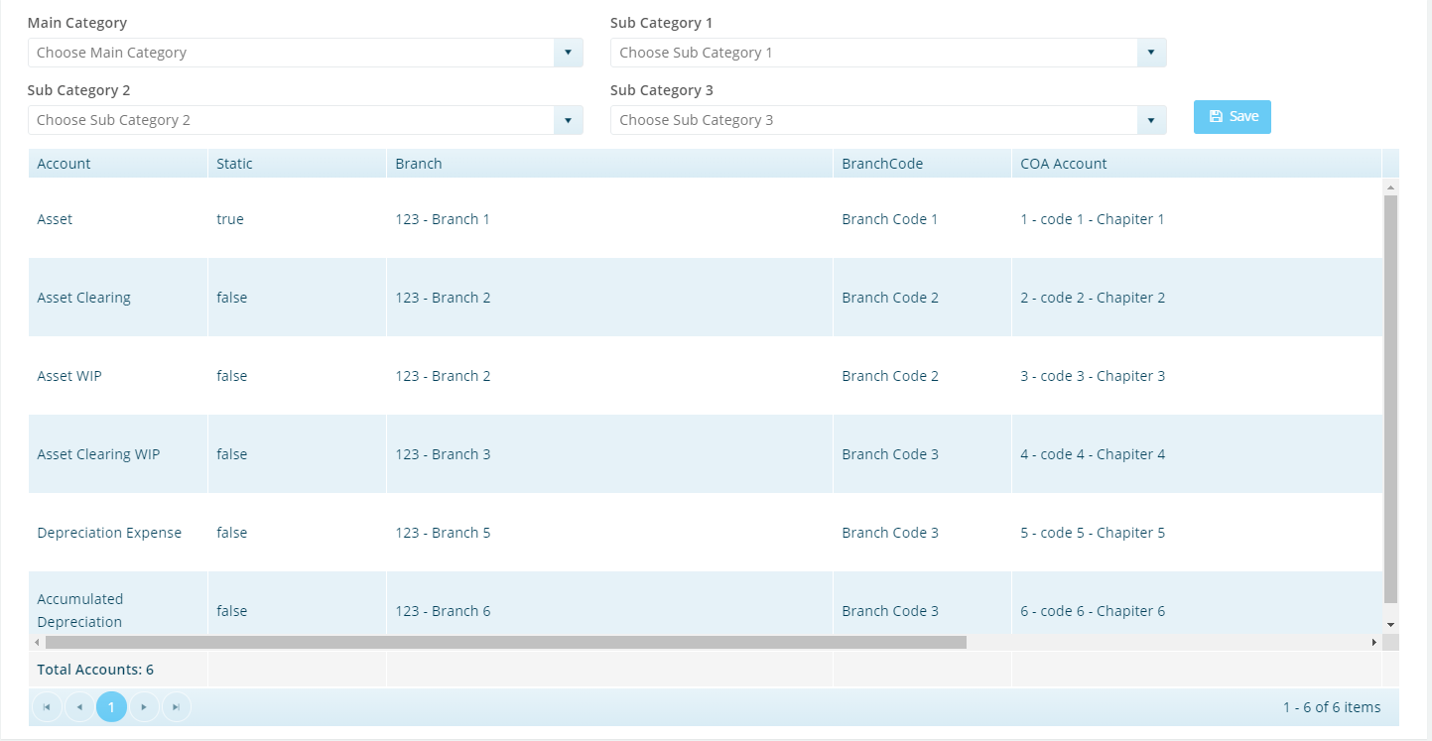

# Master Data – Cost Center

## Cost Center

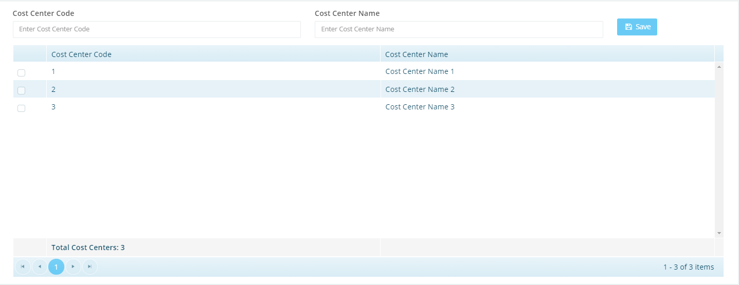

# Asset Transactions – Register

## Register Asset (Asset Information).

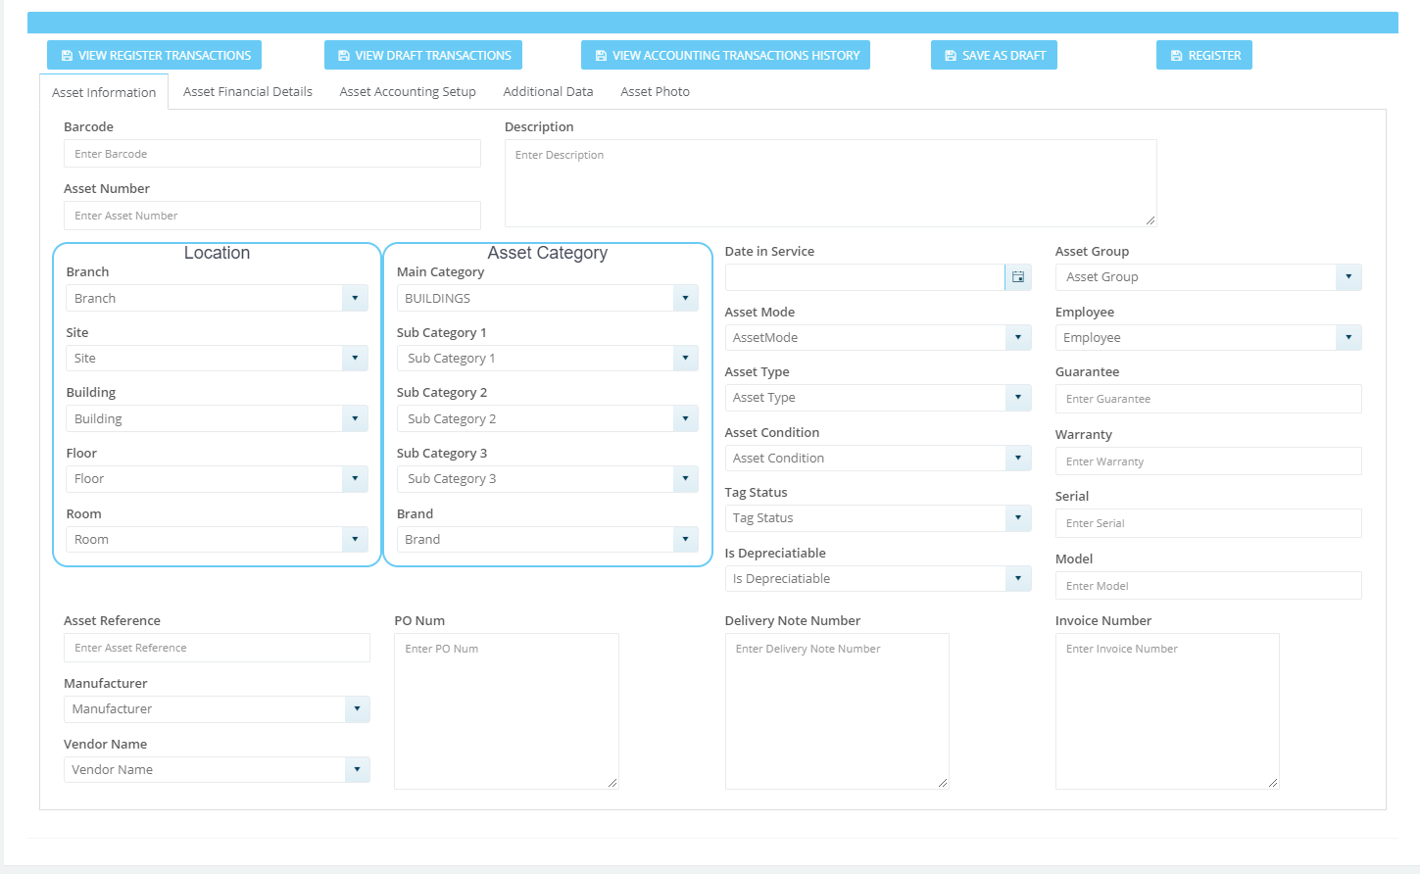

## Register Asset (Asset Financial Details)

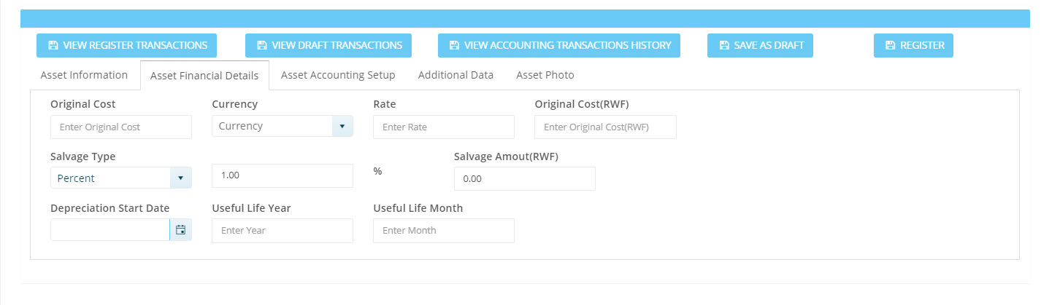

## Register Asset (Asset Accounting Setup)

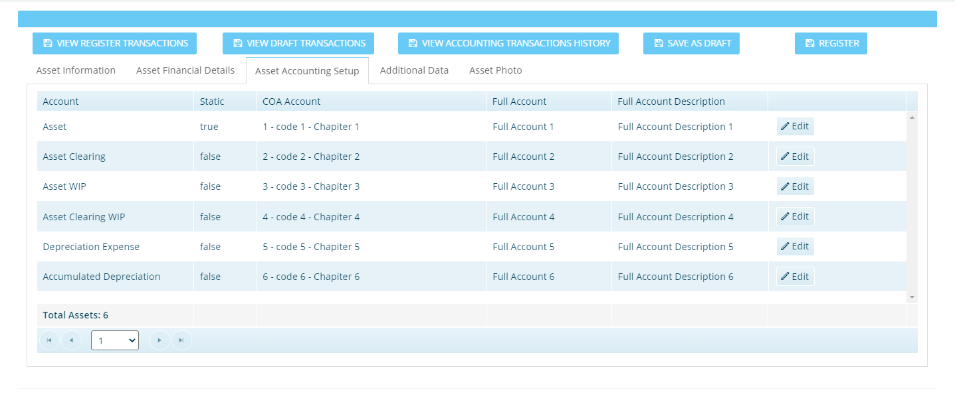

## Register Asset (Additional Data)

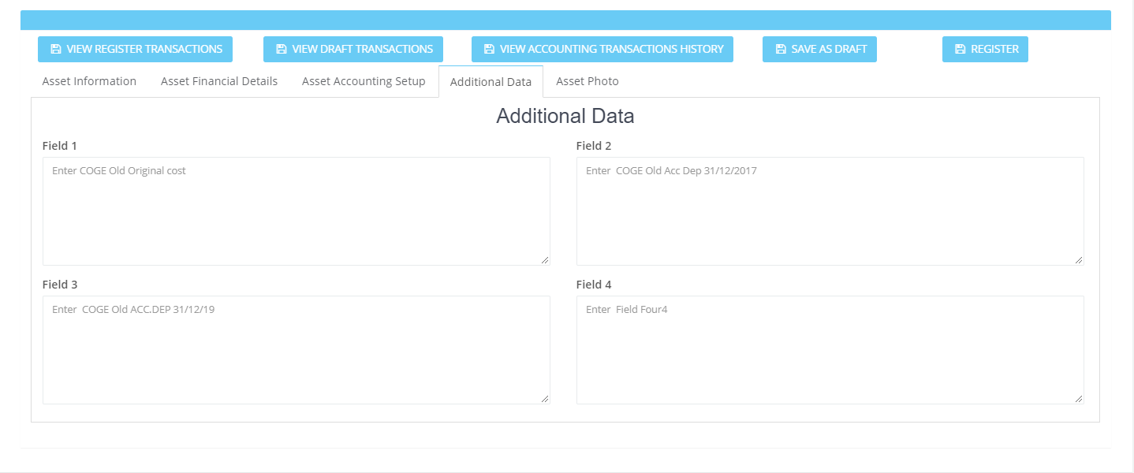

## Register Asset (Asset Photo)

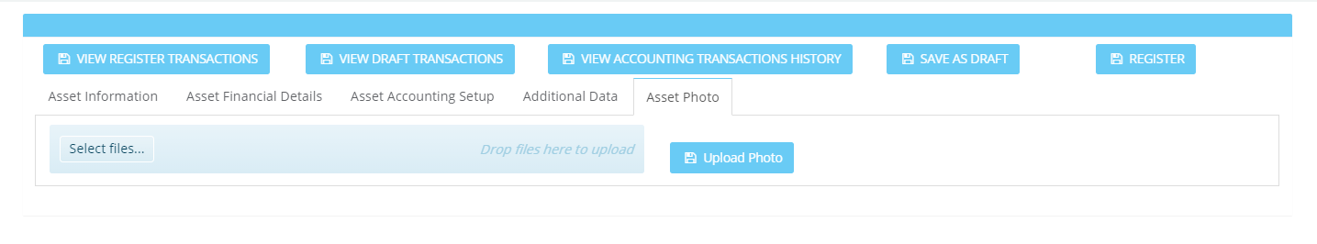

# Asset Transactions – Register

## Register IT Asset (Asset Record)

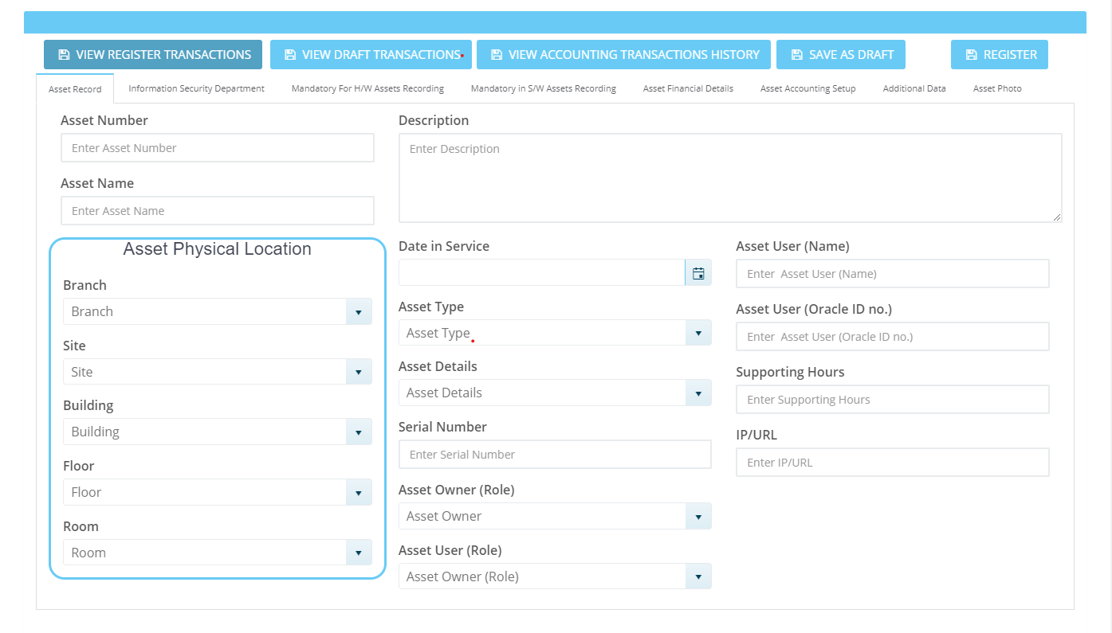

## Register IT Asset (Information Security Department)

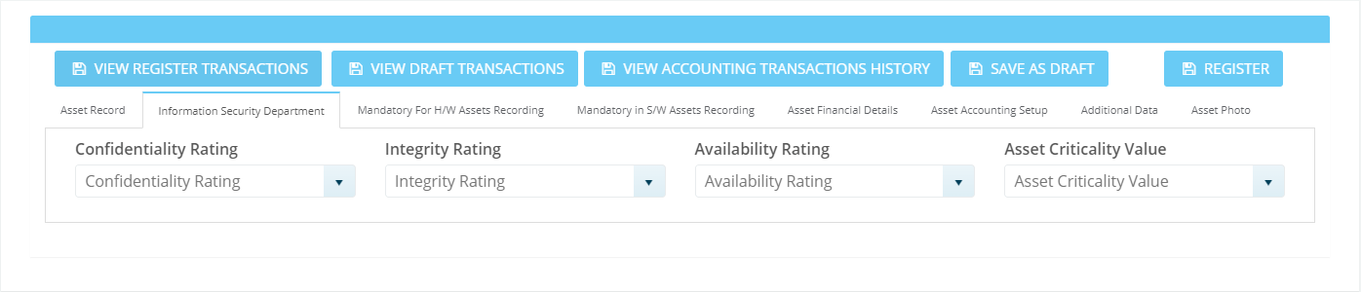

## Register IT Asset (Mandatory for H/W Assets Recording)

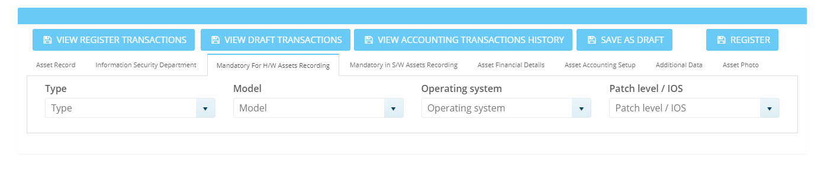

## Register IT Asset (Mandatory in S/W Assets Recording)

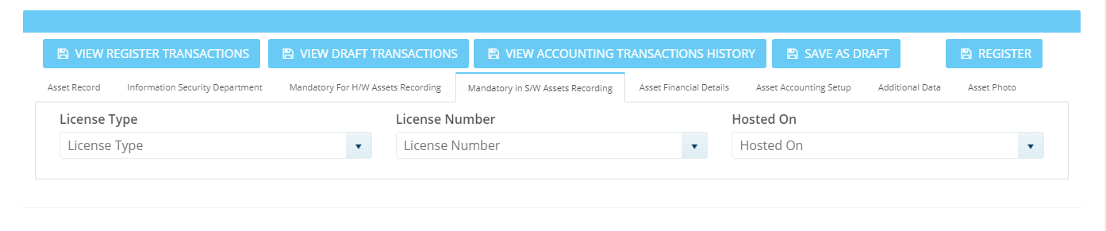

## Register IT Asset (Asset Financial Details)

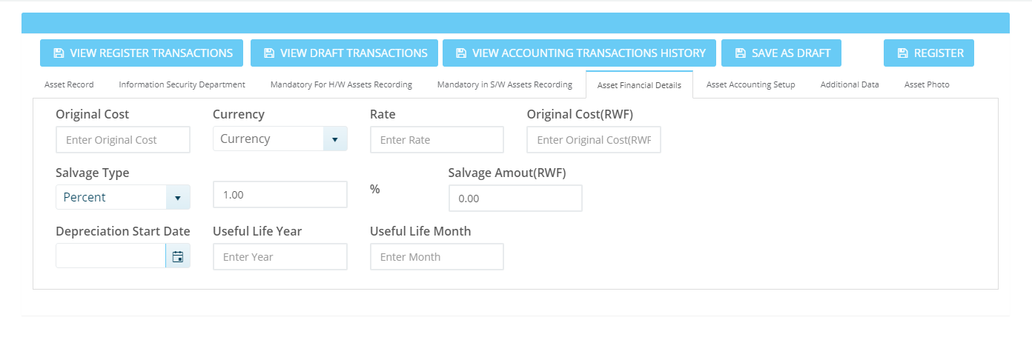

## Register IT Asset (Asset Accounting Setup)

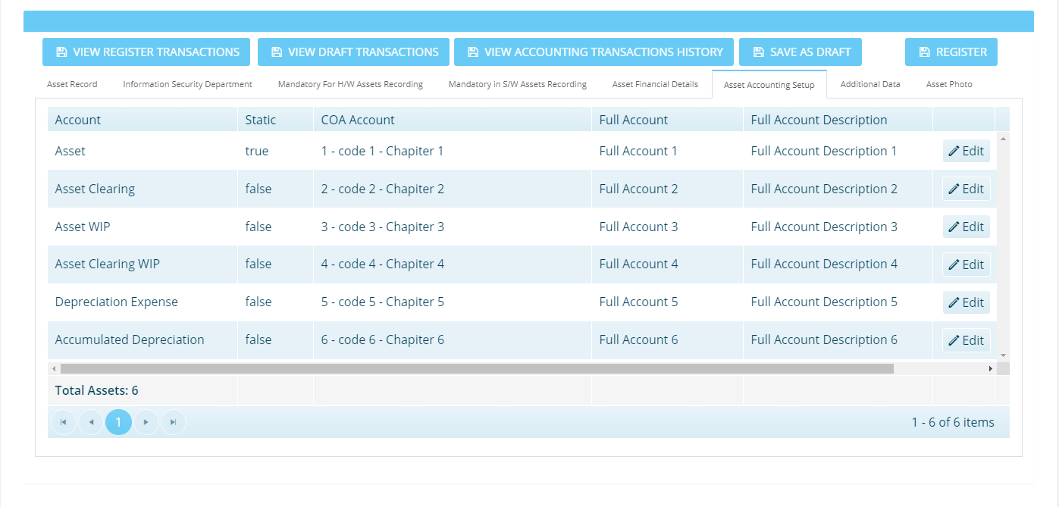

## Register IT Asset (Additional Data)

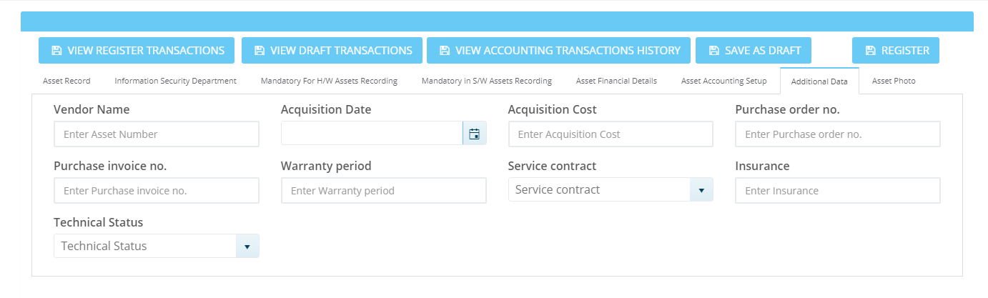

## Register IT Asset (Asset Photo)

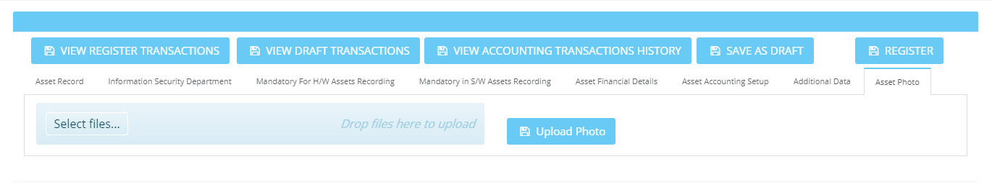

# Asset Transactions - Register

## Import & Export Asset Data



# Asset Transaction – Edit

## Edit Asset (Asset Information)

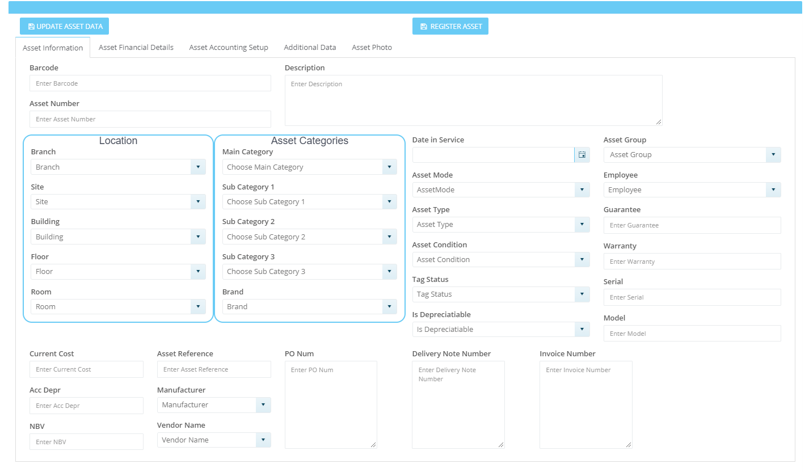

## Edit Asset (Asset Financial Details)

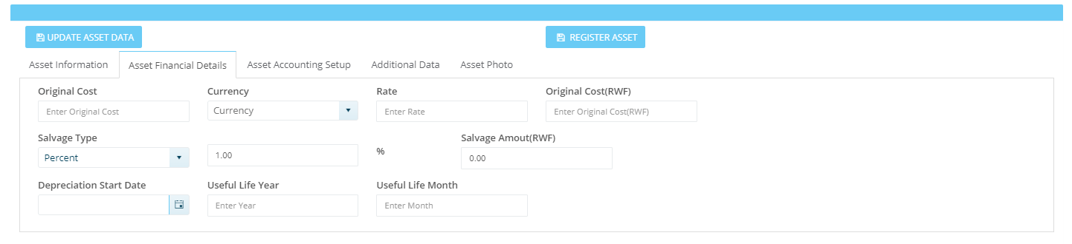

## Edit Asset (Asset Accounting Setup)

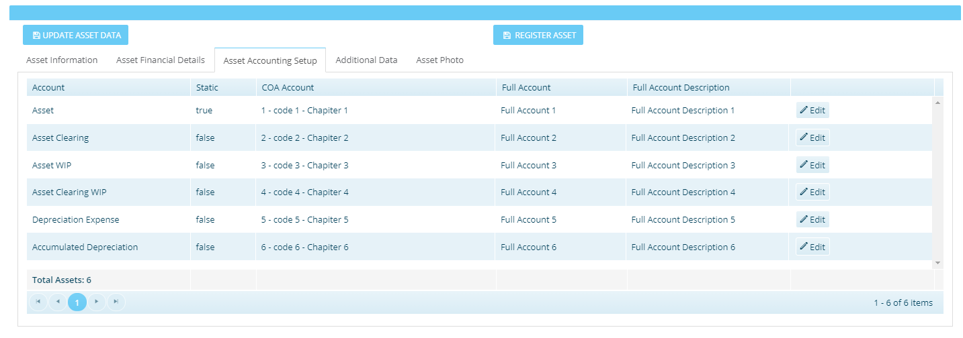

## Edit Asset (Additional Data)

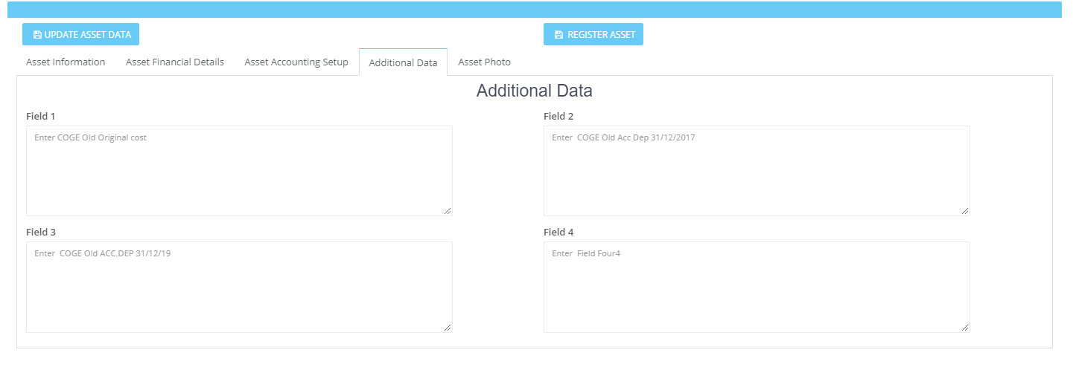

## Edit Asset (Asset Photo)

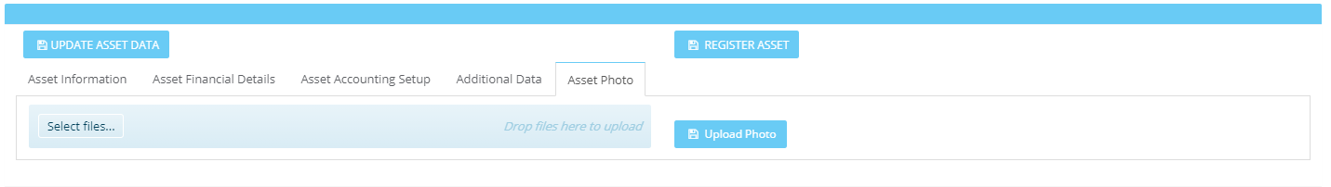

# Asset Transactions – Delete

## Delete

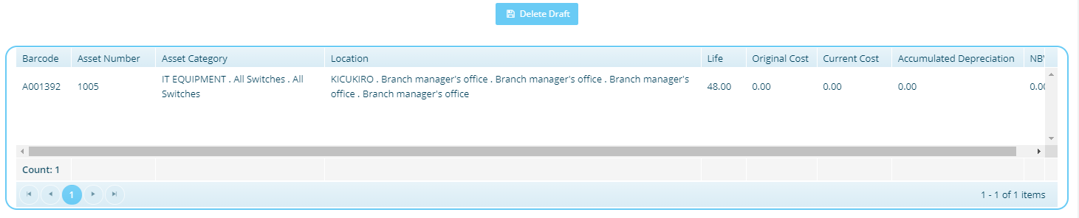

# Asset Transactions – Transfer

## Transfer

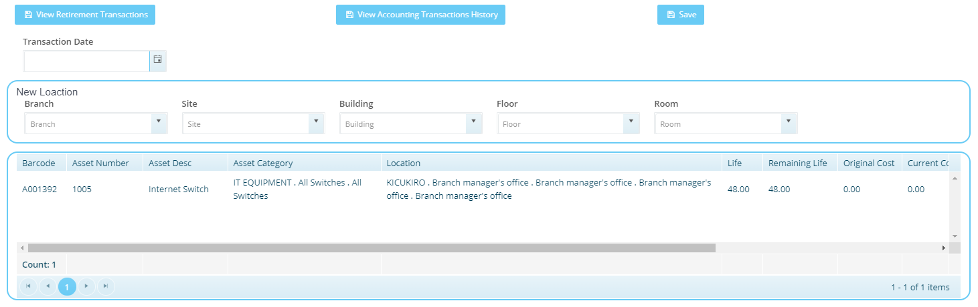

# Asset Transactions – Adjustments

## Adjust Asset

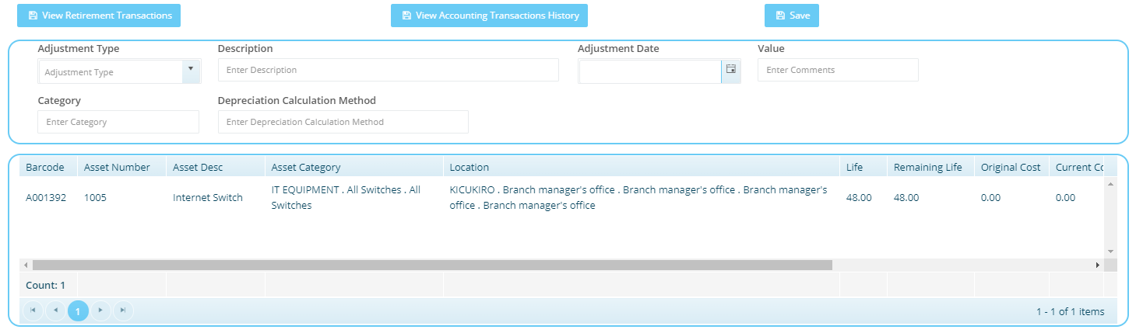

# Asset Transactions – Change Category

## Change Category

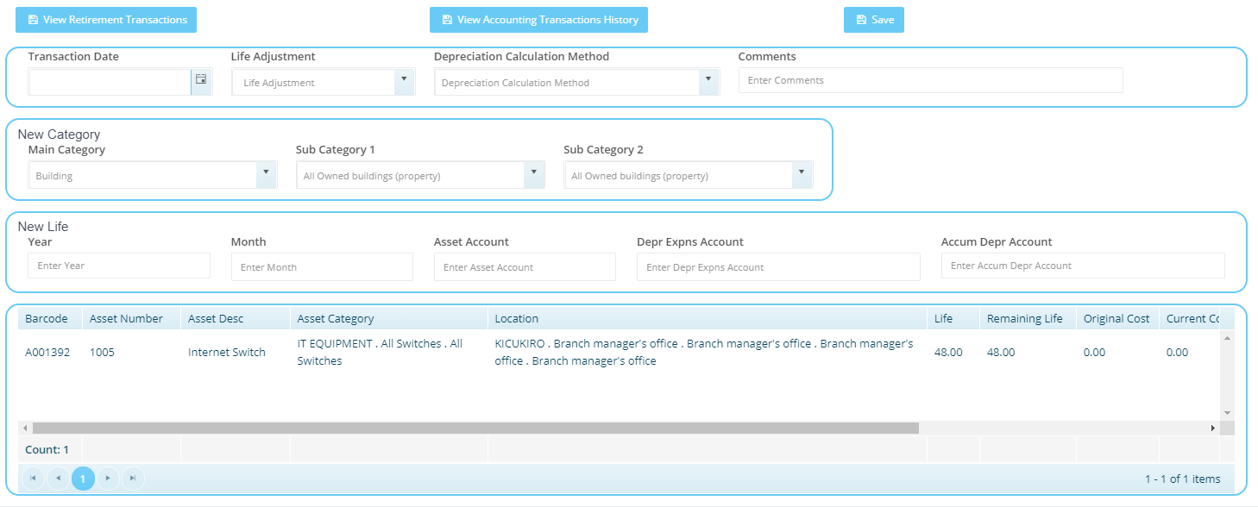

# Asset Transactions – Retirement

## Asset Retirement

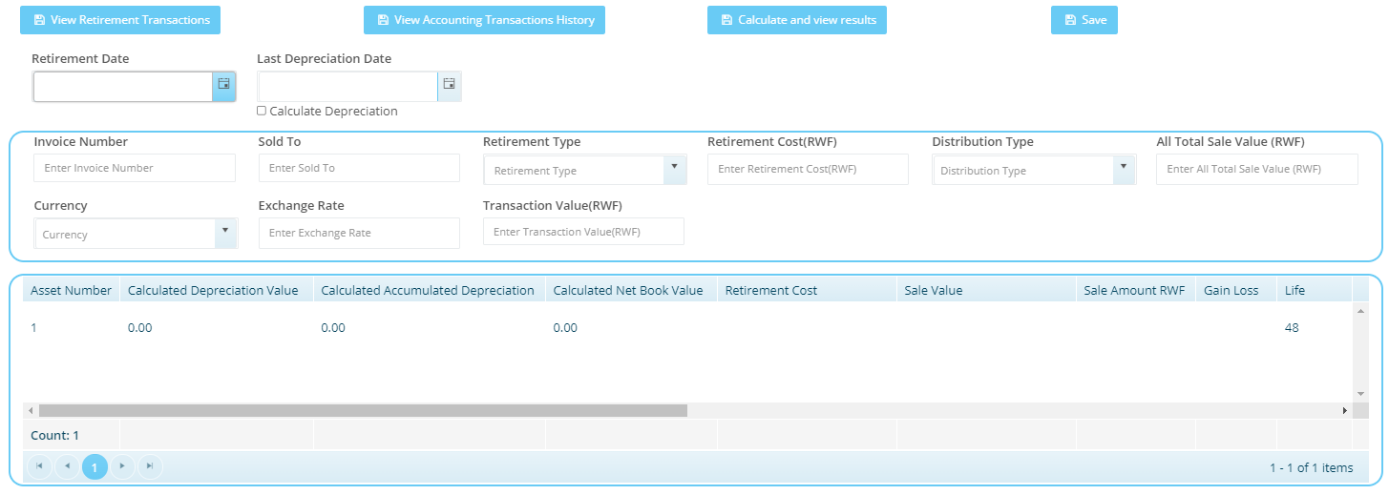

# Asset Transactions – Add to WIP Asset

## Add to WIP Asset

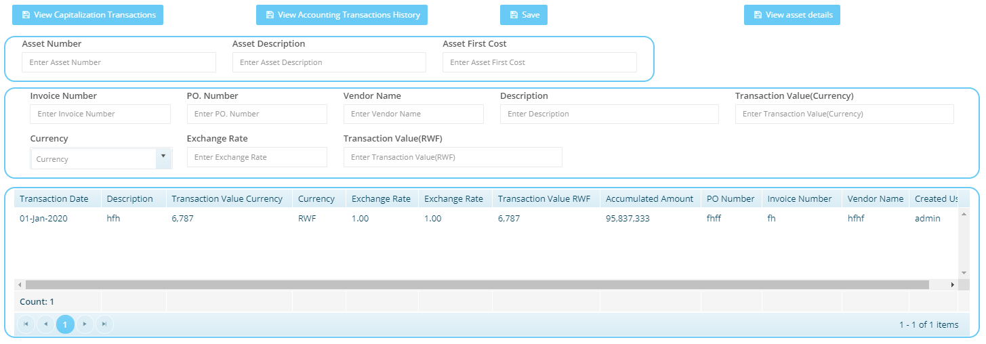

# Asset Transactions – Capitalize WIP Asset

## Capitalize WIP Asset

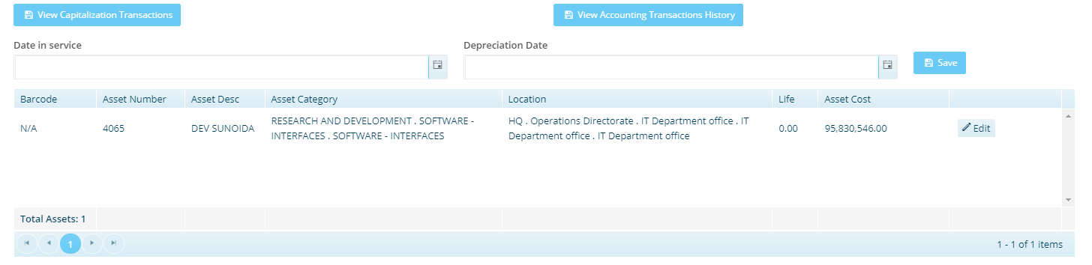

# View – View Asset

## View Asset (Asset Information)

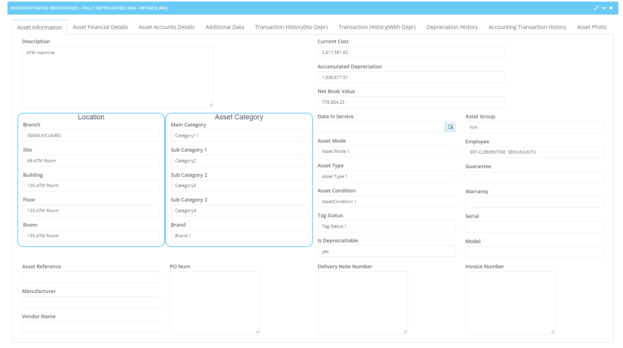

## View Asset (Asset Financial Details)

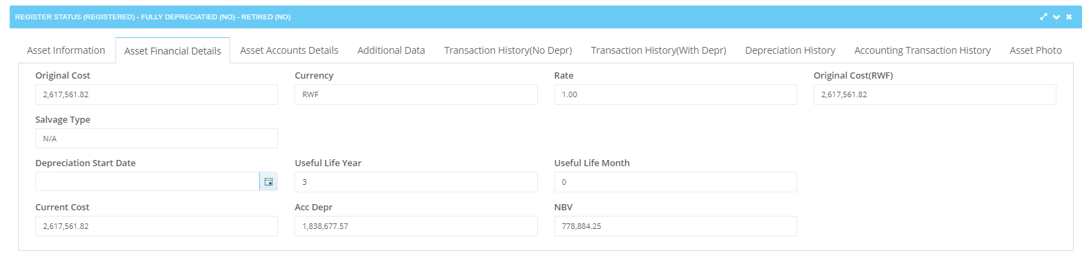

## View Asset (Asset Accounts Details)

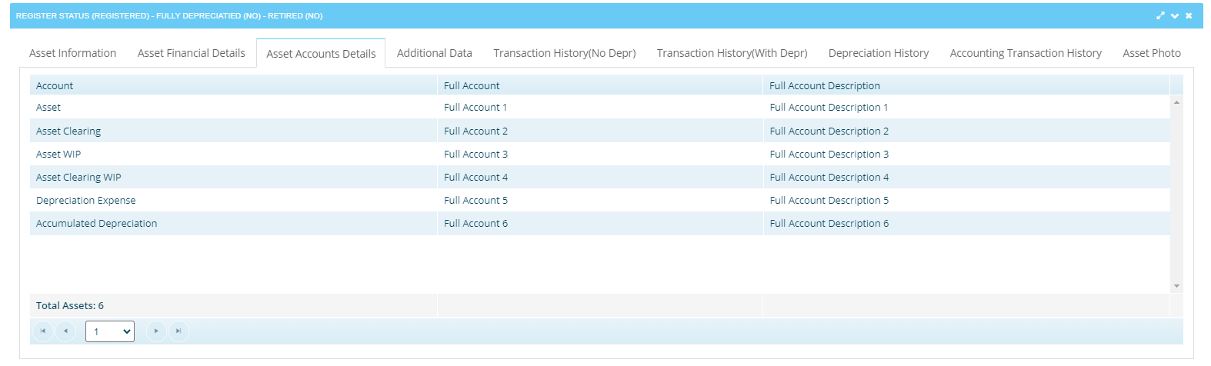

## View Asset (Additional Data)

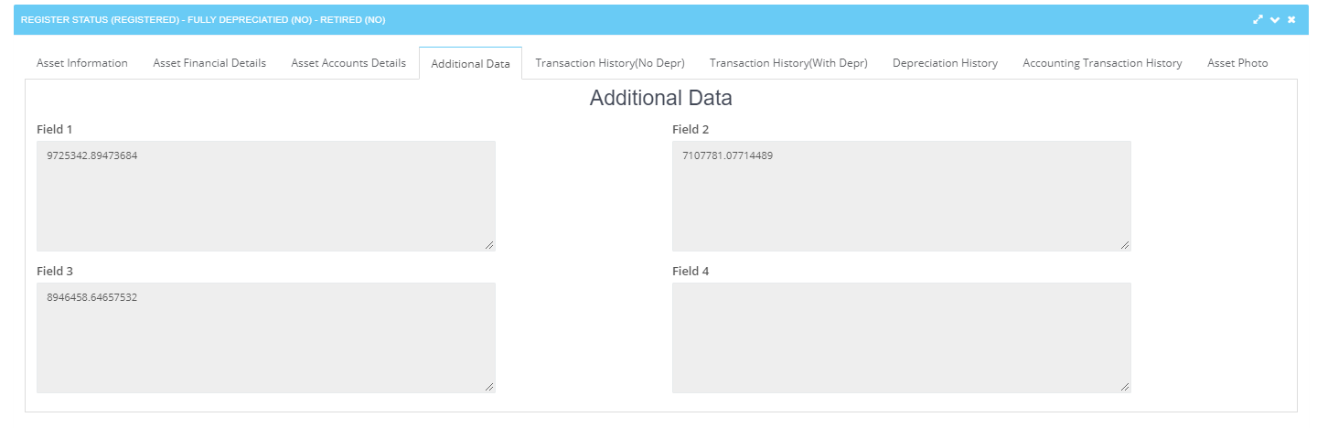

## View Asset (Transaction History (No Depr))

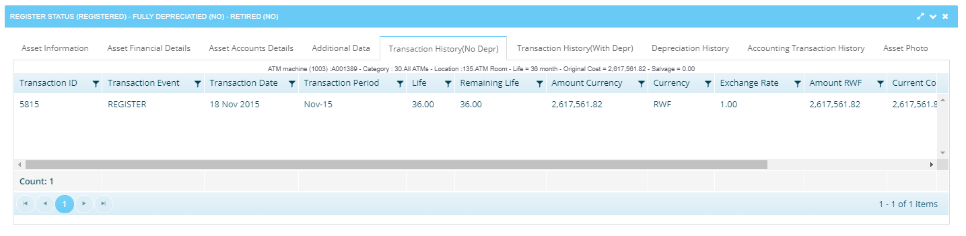

## View Asset (Transaction History (With Depr))

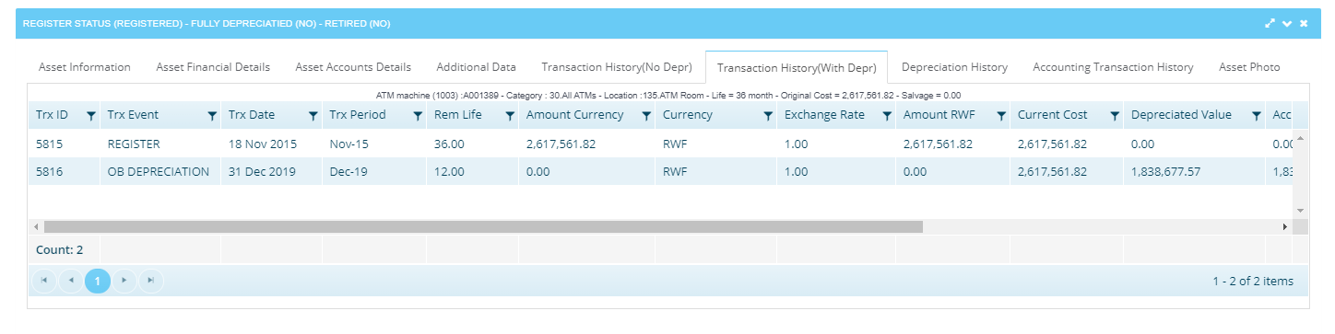

## View Asset (Depreciation History)

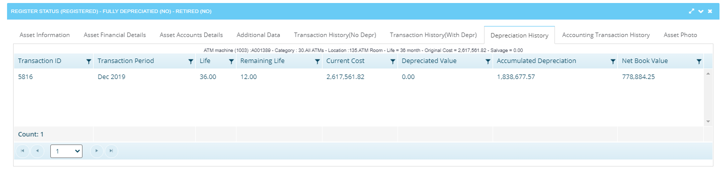

## View Asset (Accounting Transaction History)

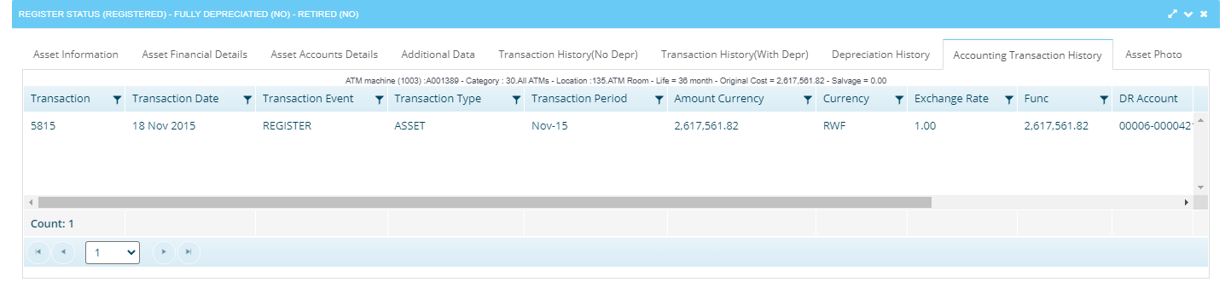

## View Asset (Asset Photo)

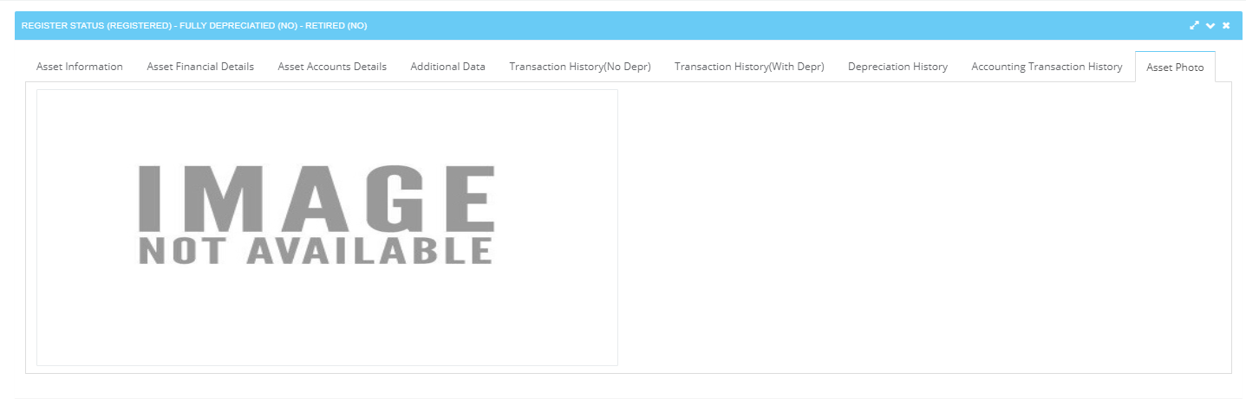

# View - View Transaction and Accounting History

## View Transaction and Accounting History

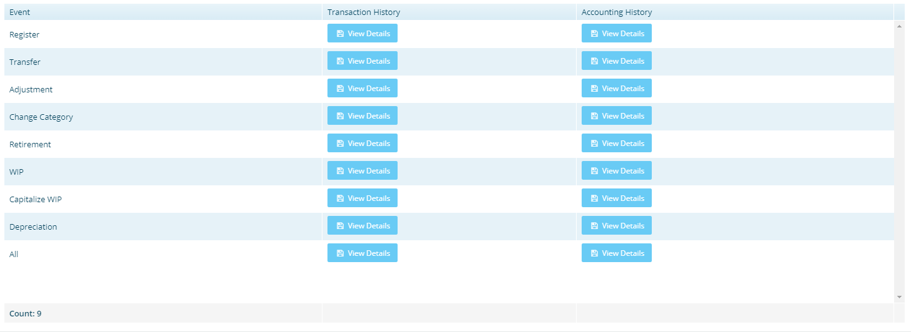

# Depreciation - Depreciation and Periods Control

## Depreciation and Periods Control

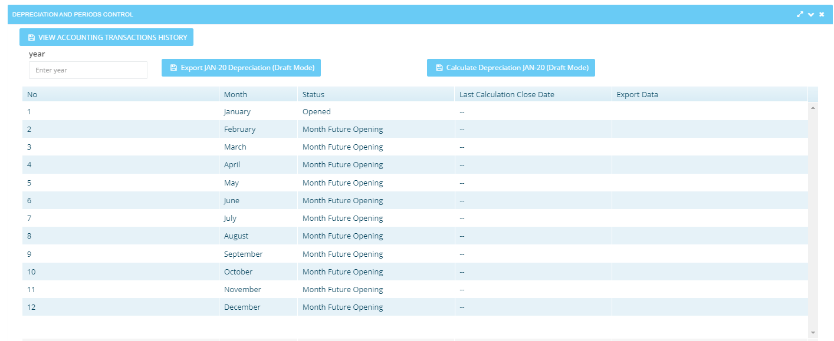

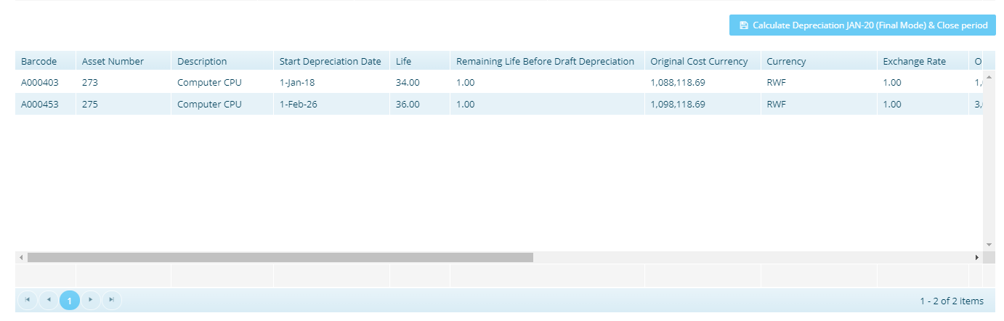

# Physical Counting – Inventory Order

## Inventory Order

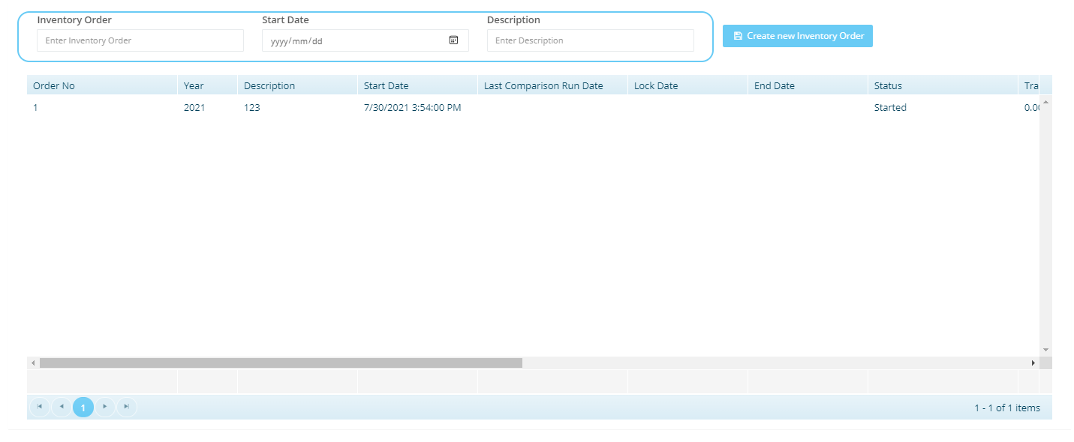

## Assign Location to Users

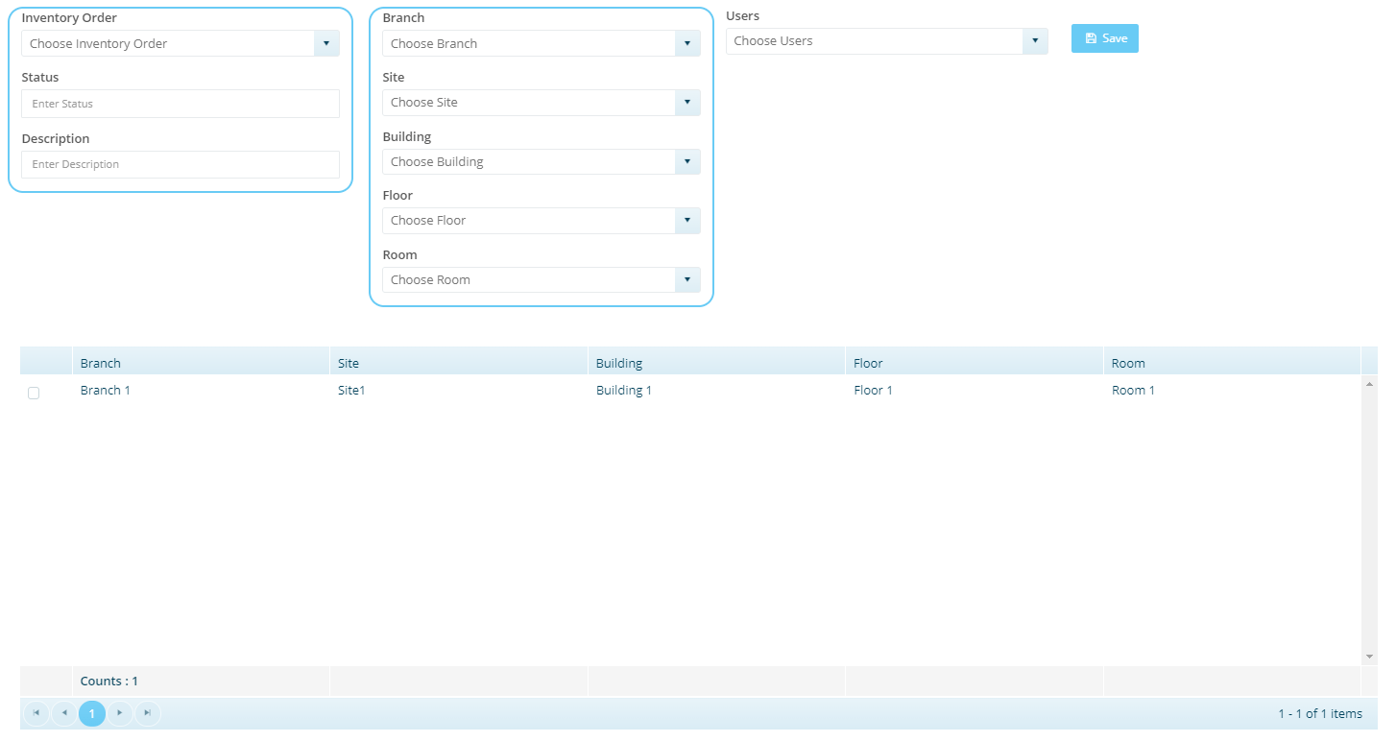

## Tracking Process

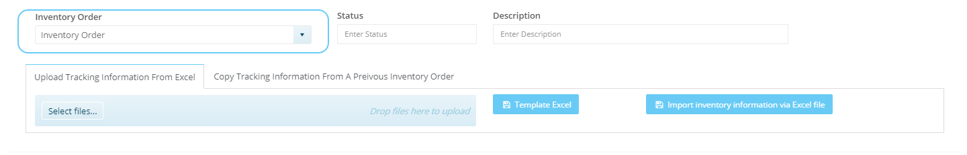

## Asset Audit Result

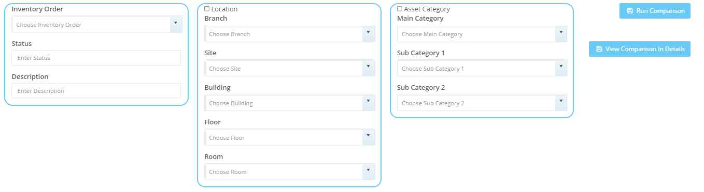

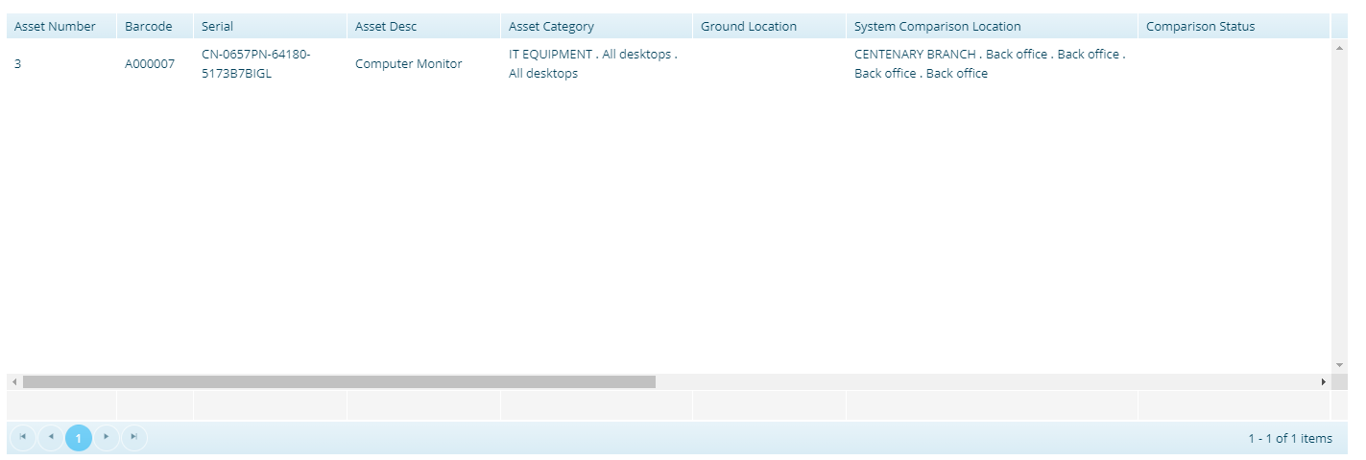

# Physical counting - Physical Count Correction Actions

## Location Difference Correction

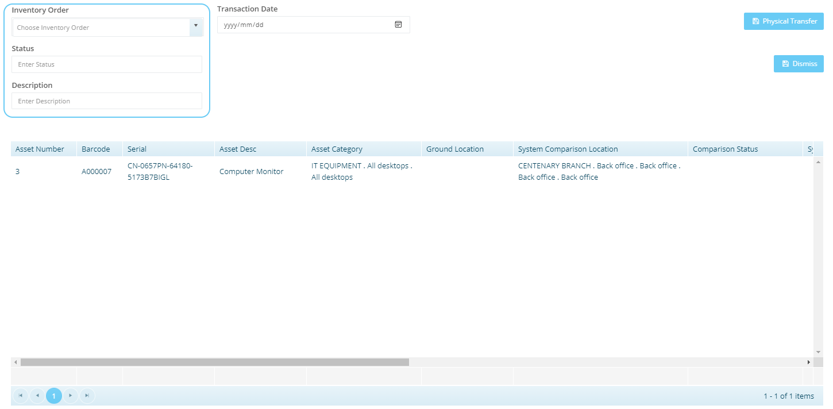

## Missing Assets Correction

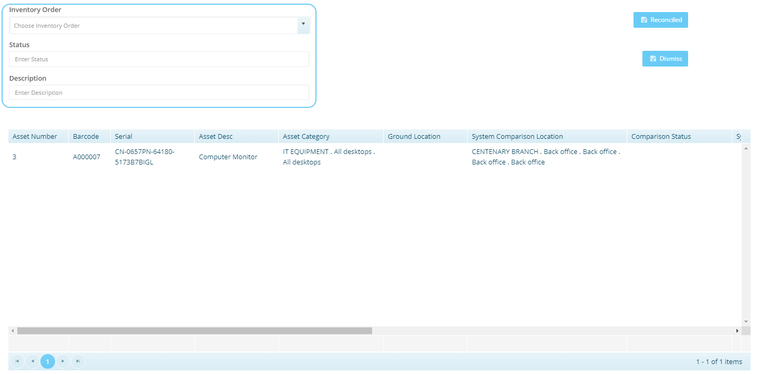

## Approve New Conditions Correction

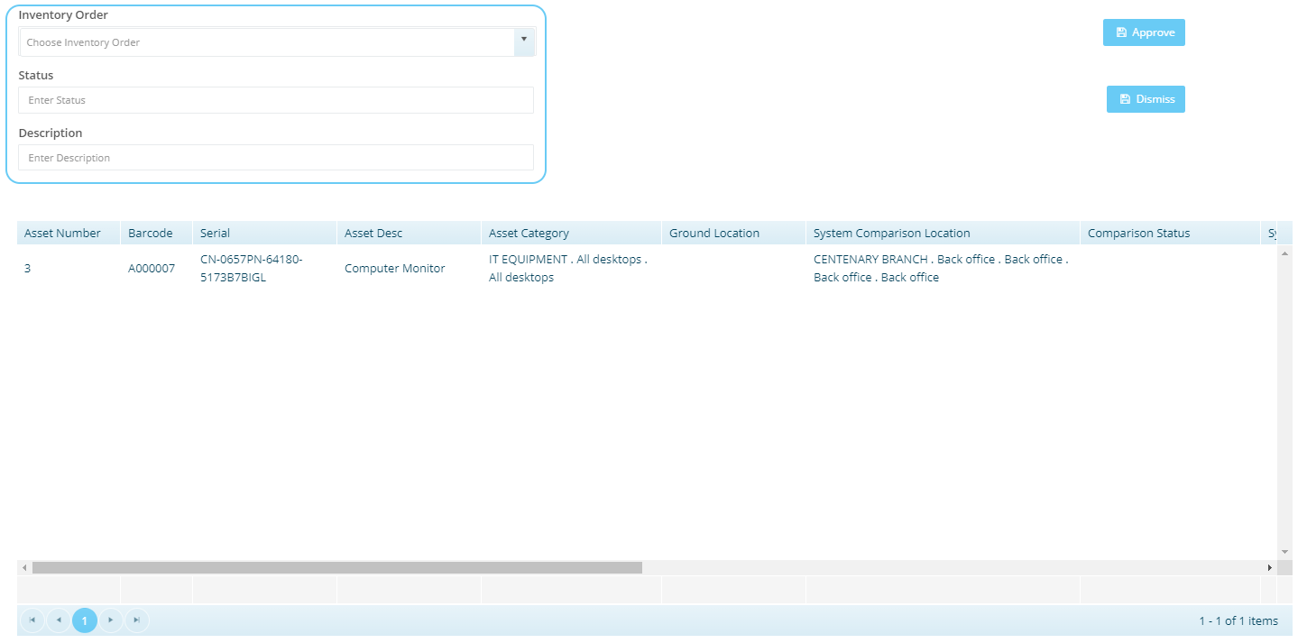

# Settings

## User

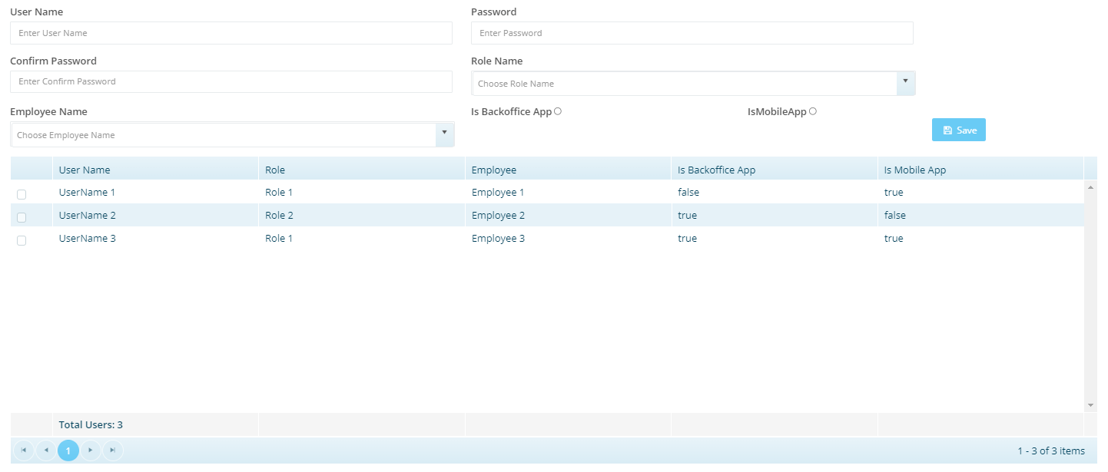

## Role

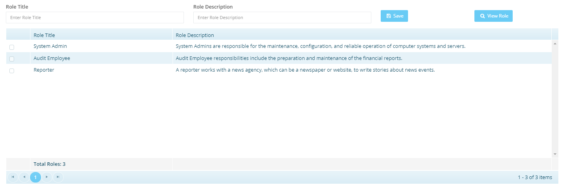

## View Role

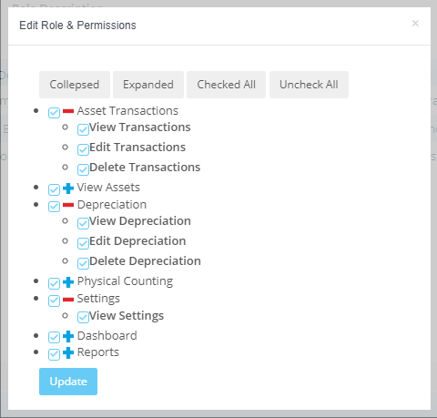

# Reports

## Menu



 